

IS313 – Data Warehousing
Course Instructors:
Ali Zidane ElQutaany
DWH_Project _ 20230340_ 20230006_ 20230602_ 20231203_ 20231144.pdf

- Mohamed Sherief
ID: 20230340

- Ahmed Ashraf
ID: 20230006

- Mahmoud Hesham
ID: 20230602

- Yasser Khaled
ID:20231203

- Mohamed Abdallah
ID:20231144

2 Physical model of the source system:
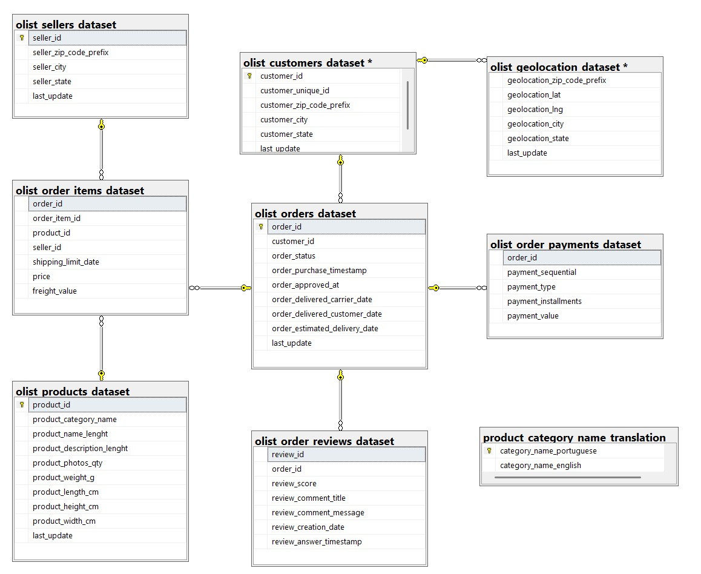
3:
4: Screenshots of the data flow tasks, and control flow tasks used for building the DWH.

Title :CUSTOMER DIM
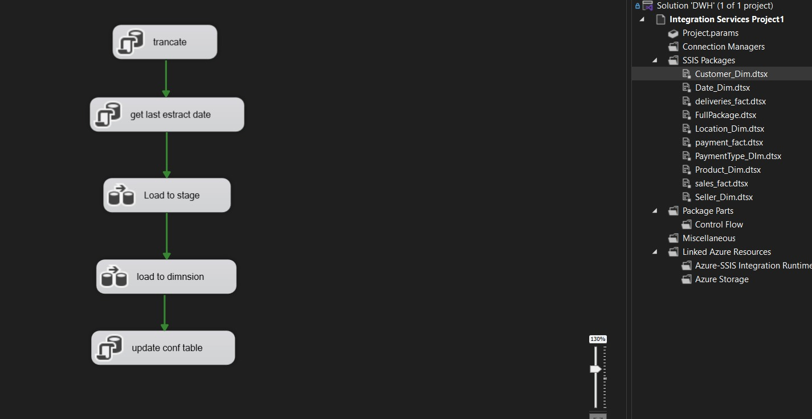

Title : deliveries fact
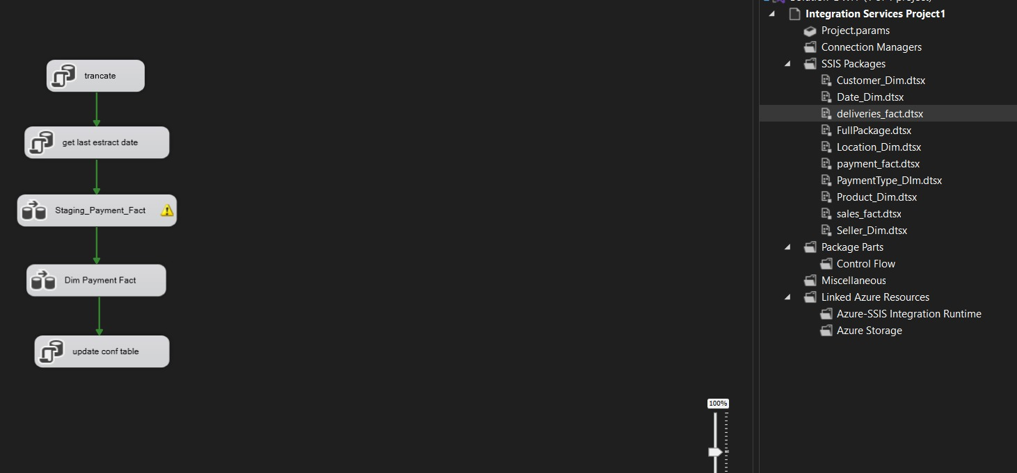
Title : Full package for deployment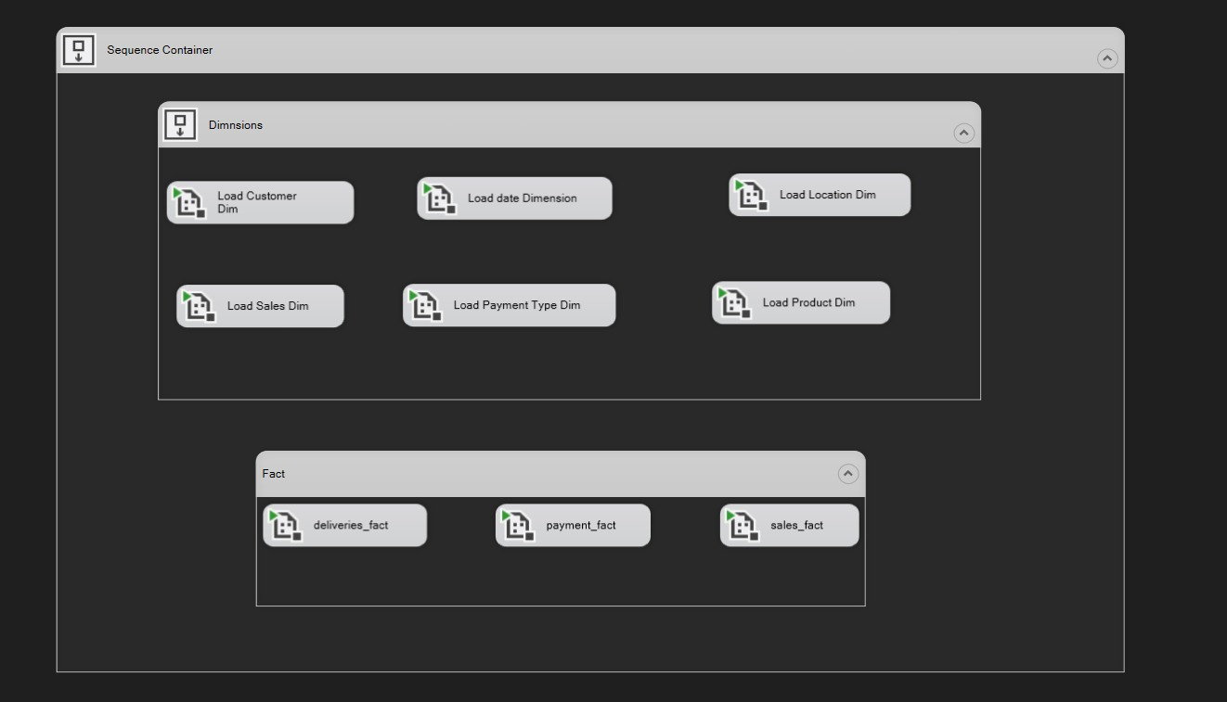

Title : location dimension
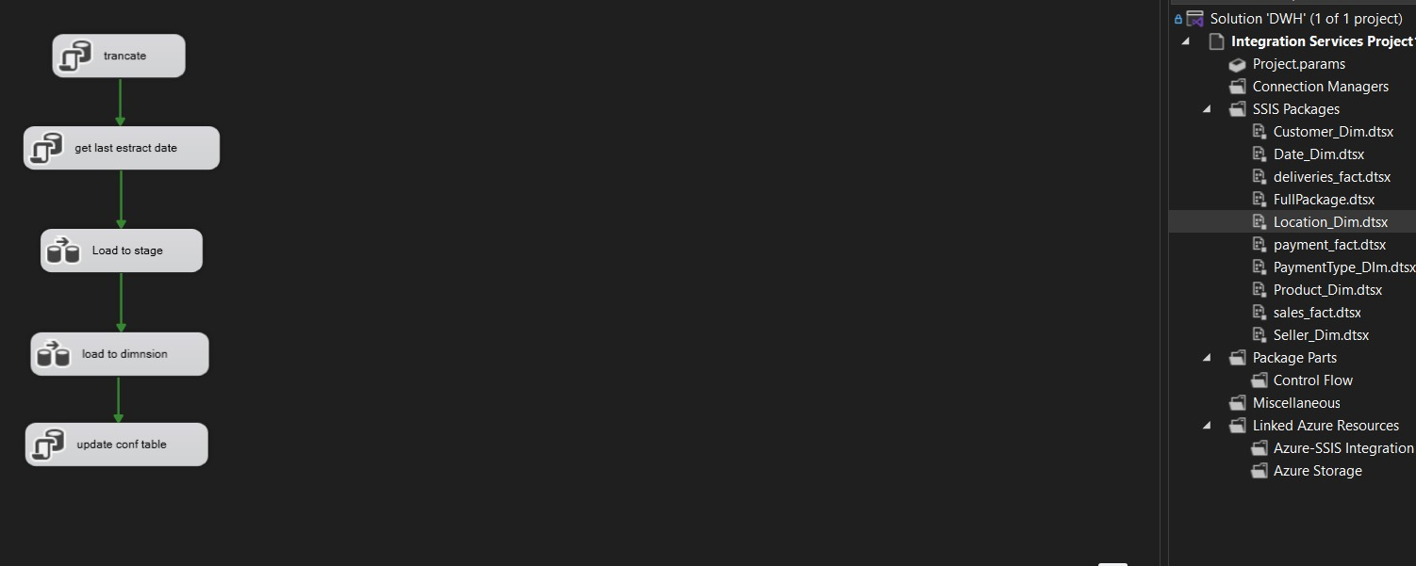

Title : Payment Fact table
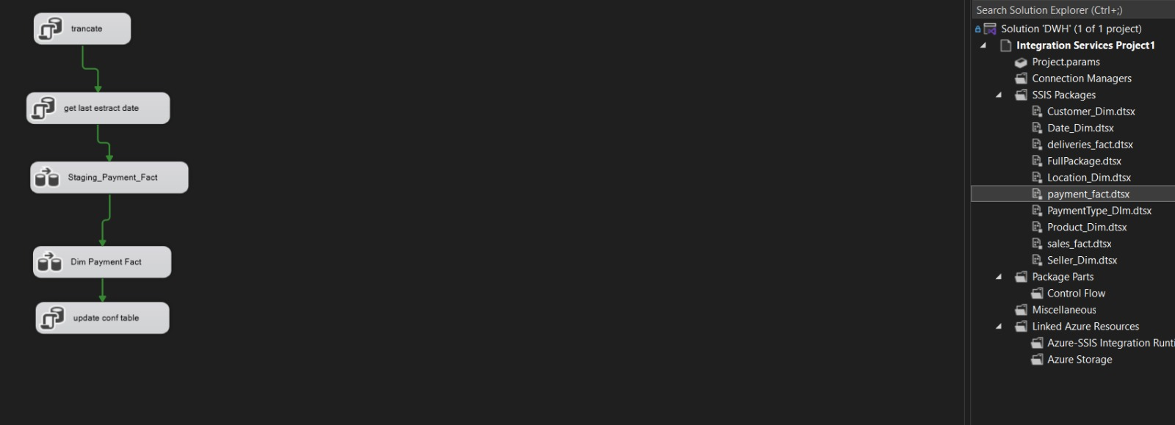
Title : Product Dim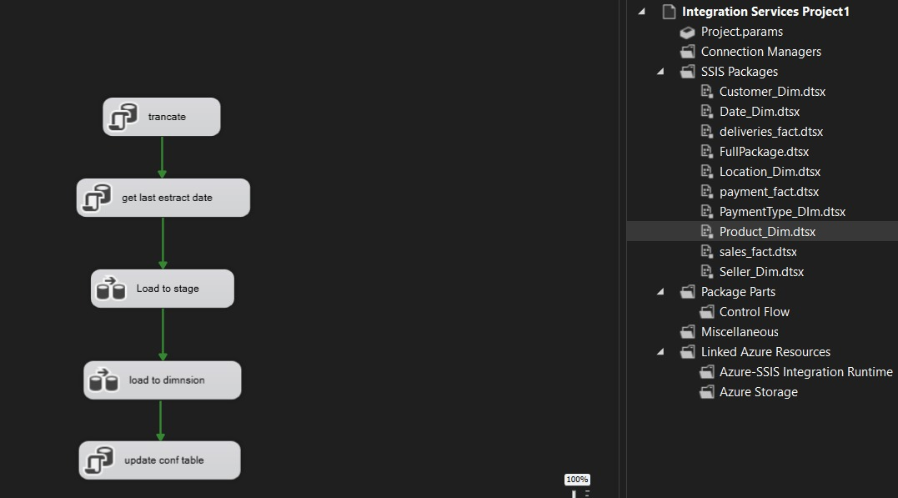

Title : stage fact table
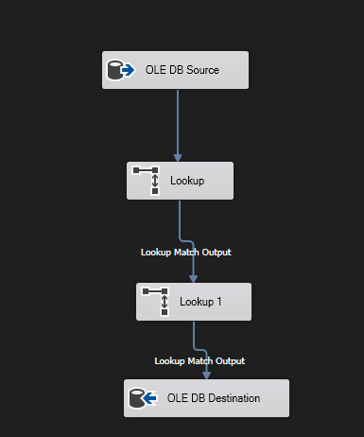
Title: load to payment fact from stage
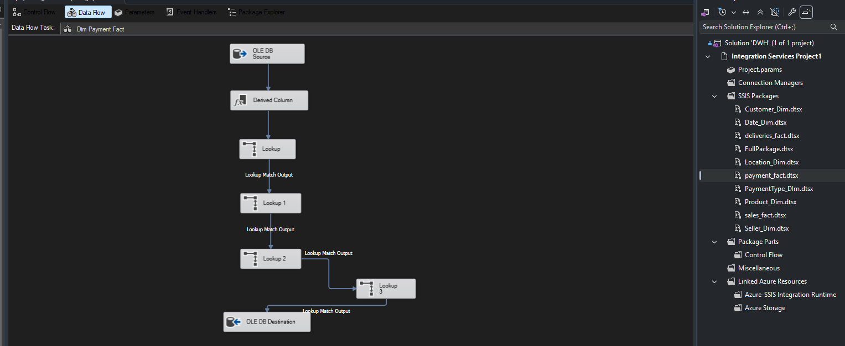
Title: load to sales fact from stage
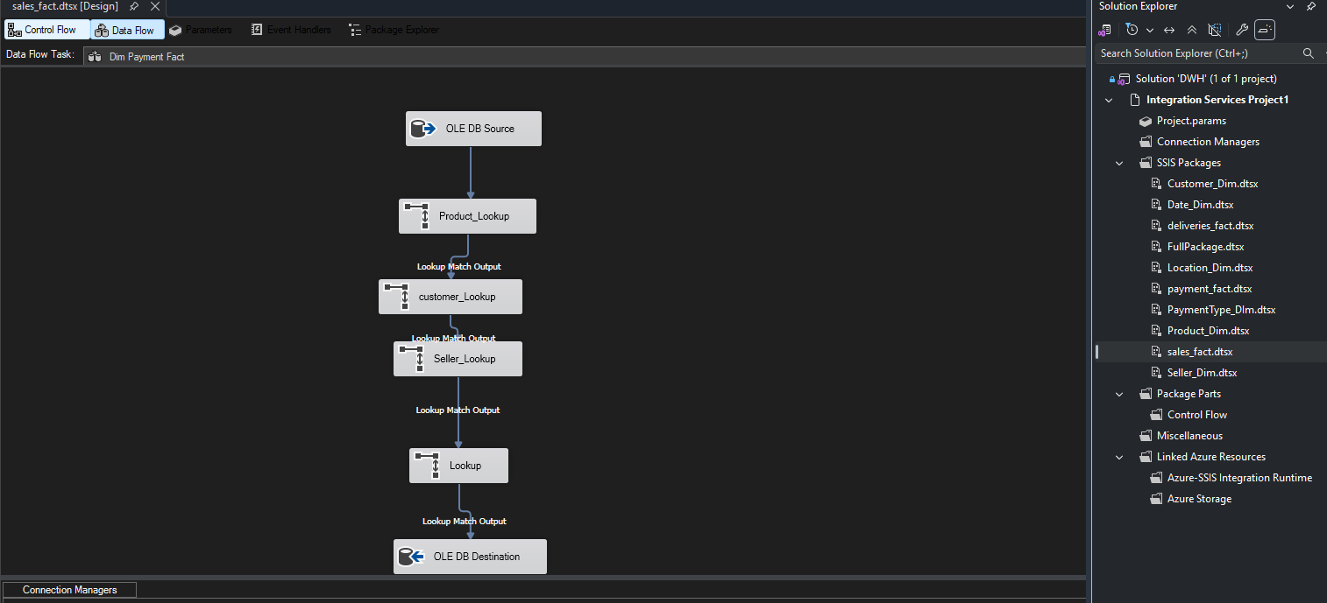
Title: load to stage sales_fact_table
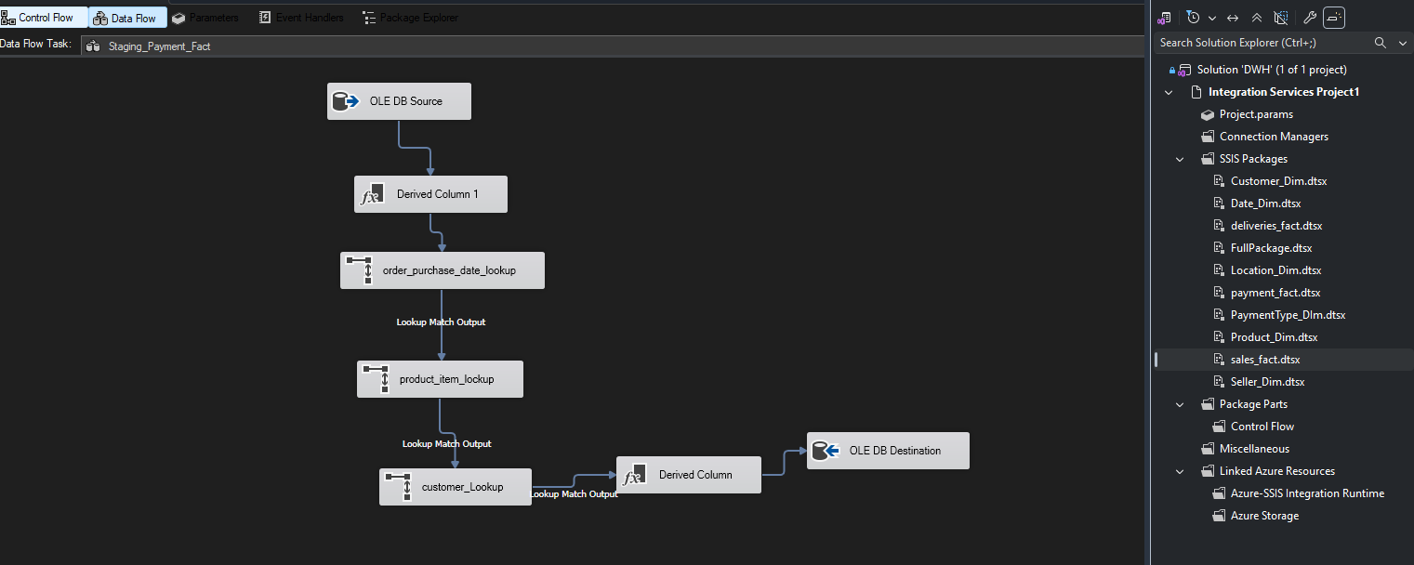

Title: load to stage in delivers fact
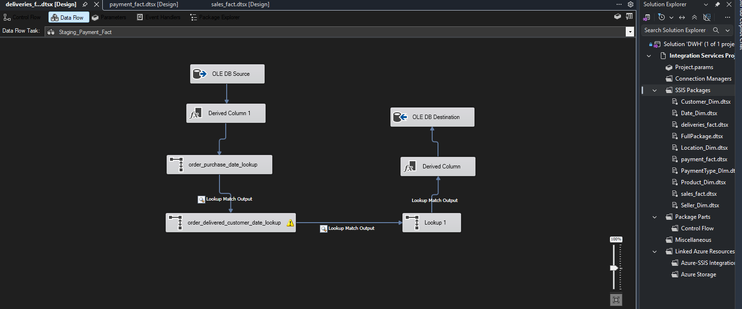

Title: load to deliveries fact from stage
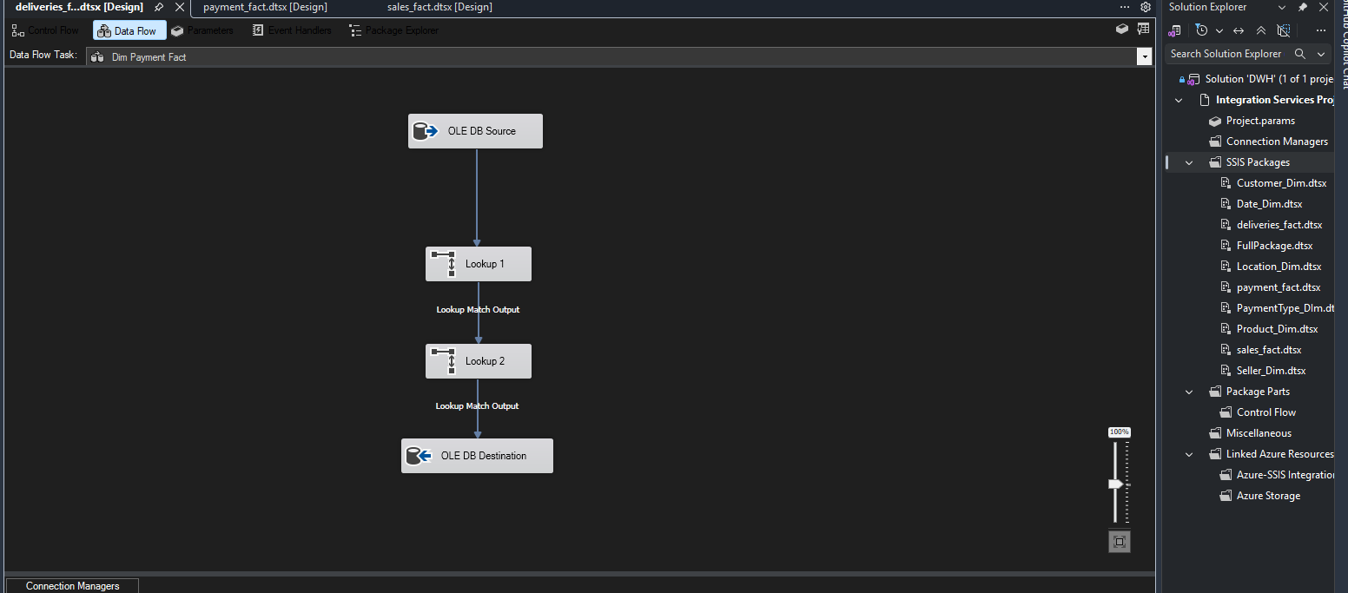

- Queries on each fact table:

@93200823902248
Below are exploratory SQL queries for each fact table in your star schema.
The goal is to help you understand:

1. **What the fact table represents**
2. **What business process it tracks**
3. **What insights/KPIs you can derive from it**

---

# 1. Fact_Sales

## What this table represents

`Fact_Sales` represents the **sales transaction line items**.

Each row likely corresponds to:

* A product sold
* In a specific order
* By a seller
* To a customer
* At a location
* On a purchase date

This is your core **revenue and product performance** fact table.

---

# Key Measures in Fact_Sales

Typical measures:

* `quantity`
* `price`
* `freight_value`
* possibly total sales value

---

# Queries for Understanding Fact_Sales

## A. Understand grain (what one row means)

```sql
SELECT TOP 10 *
FROM Fact_Sales;
```

Look for:

* Is one row = one product in an order?
* Can the same order appear multiple times?
* Are quantities > 1?

---

## B. Total revenue

```sql
SELECT
SUM(price) AS total_revenue
FROM Fact_Sales;
```

### Insight

Overall sales generated.

---

## C. Revenue by product category

```sql
SELECT
dp.product_category_name,
SUM(fs.price) AS revenue
FROM Fact_Sales fs
JOIN Dim_Product dp
ON fs.product_sk = dp.product_sk
GROUP BY dp.product_category_name
ORDER BY revenue DESC;
```

### Insight

* Best-selling categories
* Product mix
* Revenue concentration

---

## D. Top products by sales

```sql
SELECT
dp.product_category_name,
COUNT(*) AS sales_count,
SUM(fs.price) AS revenue
FROM Fact_Sales fs
JOIN Dim_Product dp
ON fs.product_sk = dp.product_sk
GROUP BY dp.product_category_name
ORDER BY revenue DESC;
```

### Insight

Identify:

* High-demand products
* Revenue drivers

---

## E. Sales trend over time

```sql
SELECT
dd.year,
dd.month,
SUM(fs.price) AS monthly_sales
FROM Fact_Sales fs
JOIN Dim_Date dd
ON fs.order_purchase_date_sk = dd.date_sk
GROUP BY dd.year, dd.month
ORDER BY dd.year, dd.month;
```

### Insight

* Seasonality
* Growth trends
* Peak months

---

## F. Seller performance

```sql
SELECT
ds.seller_state,
COUNT(DISTINCT fs.order_bk) AS orders,
SUM(fs.price) AS revenue
FROM Fact_Sales fs
JOIN Dim_Seller ds
ON fs.seller_sk = ds.seller_sk
GROUP BY ds.seller_state
ORDER BY revenue DESC;
```

### Insight

* Best performing regions
* Seller distribution

---

## G. Average order value

```sql
SELECT
AVG(order_total) AS avg_order_value
FROM (
SELECT
order_bk,
SUM(price) AS order_total
FROM Fact_Sales
GROUP BY order_bk
) t;
```

### Insight

Customer purchasing behavior.

---

# 2. Fact_Payments

## What this table represents

Tracks **how customers paid for orders**.

This table captures:

* Payment method
* Installments
* Payment value
* Payment timing

This is your **financial/payment behavior** fact table.

---

# Key Measures

* `payment_value`
* `payment_installments`
* payment sequence

---

# Queries for Understanding Fact_Payments

## A. Explore payment records

```sql
SELECT TOP 10 *
FROM Fact_Payments;
```

---

## B. Revenue collected

```sql
SELECT
SUM(payment_value) AS total_payments
FROM Fact_Payments;
```

### Insight

Actual payments received.

---

## C. Most used payment methods

```sql
SELECT
dpt.payment_type_name,
COUNT(*) AS usage_count,
SUM(fp.payment_value) AS total_paid
FROM Fact_Payments fp
JOIN Dim_Payment_Type dpt
ON fp.payment_type_sk = dpt.payment_type_sk
GROUP BY dpt.payment_type_name
ORDER BY usage_count DESC;
```

### Insight

* Credit card dominance
* Customer payment preferences

---

## D. Installment behavior

```sql
SELECT
payment_installments,
COUNT(*) AS num_transactions,
AVG(payment_value) AS avg_payment
FROM Fact_Payments
GROUP BY payment_installments
ORDER BY payment_installments;
```

### Insight

* Financing behavior
* Large purchases tendency

---

## E. Payments over time

```sql
SELECT
dd.year,
dd.month,
SUM(fp.payment_value) AS payment_amount
FROM Fact_Payments fp
JOIN Dim_Date dd
ON fp.payment_date_sk = dd.date_sk
GROUP BY dd.year, dd.month
ORDER BY dd.year, dd.month;
```

### Insight

Cash flow trends.

---

## F. Average payment per customer

```sql
SELECT
dc.customer_unique_id,
AVG(fp.payment_value) AS avg_payment
FROM Fact_Payments fp
JOIN Dim_Customer dc
ON fp.customer_sk = dc.customer_sk
GROUP BY dc.customer_unique_id
ORDER BY avg_payment DESC;
```

### Insight

High-value customers.

---

# 3. Fact_Deliveries

## What this table represents

Tracks the **order fulfillment and logistics process**.

This is your operational/logistics fact table.

It measures:

* Delivery times
* Shipping performance
* Customer fulfillment experience

---

# Key Measures

* `delivery_time_days`
* order dates vs delivery dates

---

# Queries for Understanding Fact_Deliveries

## A. Explore delivery records

```sql
SELECT TOP 10 *
FROM Fact_Deliveries;
```

---

## B. Average delivery time

```sql
SELECT
AVG(delivery_time_days) AS avg_delivery_days
FROM Fact_Deliveries;
```

### Insight

Overall logistics efficiency.

---

## C. Delivery performance by state

```sql
SELECT
dl.state,
AVG(fd.delivery_time_days) AS avg_delivery_days
FROM Fact_Deliveries fd
JOIN Dim_Location dl
ON fd.location_sk = dl.location_sk
GROUP BY dl.state
ORDER BY avg_delivery_days;
```

### Insight

* Fastest delivery regions
* Problematic logistics areas

---

## D. Monthly delivery trends

```sql
SELECT
dd.year,
dd.month,
AVG(fd.delivery_time_days) AS avg_delivery
FROM Fact_Deliveries fd
JOIN Dim_Date dd
ON fd.order_purchase_date_sk = dd.date_sk
GROUP BY dd.year, dd.month
ORDER BY dd.year, dd.month;
```

### Insight

Operational performance over time.

---

## E. Orders delivered late

(assuming estimated_delivery_days exists)

```sql
SELECT
COUNT(*) AS late_orders
FROM Fact_Deliveries
WHERE delivery_time_days > estimated_delivery_days;
```

### Insight

Customer satisfaction risk.

---

## F. Delivery distribution

```sql
SELECT
delivery_time_days,
COUNT(*) AS num_orders
FROM Fact_Deliveries
GROUP BY delivery_time_days
ORDER BY delivery_time_days;
```

### Insight

Delivery consistency and SLA adherence.

---

# Understanding the Overall Business Model

Your warehouse is modeling 3 major business processes:

| Fact Table | Business Process | Main Questions |
| --------------- | ------------------ | --------------------- |
| Fact_Sales | Sales transactions | What was sold? |
| Fact_Payments | Payment processing | How was it paid? |
| Fact_Deliveries | Order fulfillment | How was it delivered? |

---

# Cross-Fact Insights (Very Important)

Because all fact tables share:

* `order_bk`
* `customer_sk`
* `location_sk`

You can combine them for deeper analytics.

---

# Example: Sales vs Delivery Speed

```sql
SELECT
dp.product_category_name,
AVG(fd.delivery_time_days) AS avg_delivery,
SUM(fs.price) AS revenue
FROM Fact_Sales fs
JOIN Fact_Deliveries fd
ON fs.order_bk = fd.order_bk
JOIN Dim_Product dp
ON fs.product_sk = dp.product_sk
GROUP BY dp.product_category_name
ORDER BY revenue DESC;
```

### Insight

Do expensive/high-volume products suffer from slow delivery?

---

# Example: Payment Type vs Order Value

```sql
SELECT
dpt.payment_type_name,
AVG(fs.price) AS avg_order_value
FROM Fact_Sales fs
JOIN Fact_Payments fp
ON fs.order_bk = fp.order_bk
JOIN Dim_Payment_Type dpt
ON fp.payment_type_sk = dpt.payment_type_sk
GROUP BY dpt.payment_type_name;
```

### Insight

Which payment methods are associated with larger purchases?

---

# Final Interpretation

Your schema is a classic **Retail/E-Commerce Star Schema**:

* `Fact_Sales` → commercial performance
* `Fact_Payments` → financial behavior
* `Fact_Deliveries` → logistics performance

Together they allow:

* Revenue analytics
* Customer analytics
* Operational analytics
* Geographic analytics
* Product analytics
* Payment behavior analysis
* Supply chain KPIs

This is very close to a real-world enterprise BI warehouse design.

- Screenshots of the deployed packages in SSIS with their schedule:

